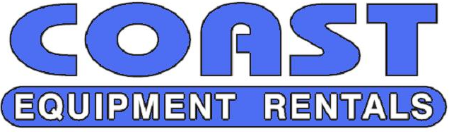
1713 WEST VISTA WAY
VISTA, CA 92083
(800) 361-4500
(760) 941-8003
FAX: (760) 630-8384
Email: info@coastequipmentrental.com

MASTER RENTAL CONTRACT / AGREEMENT

In lieu of getting a signature on the requested rental item, this master rental contract will serve as a blanket agreement to the attached Coast Equipment Rental Agreement of each Rental Contract for equipment delivered by Coast Equipment Rentals. Please have an owner or officer review and sign both:

- This Page
- The bottom signature line of the Coast Equipment Rental Agreement page

In the event that no signed Rental Contract is obtained, an unsigned Rental Contract shall have the full force and effect as a signed Rental Contract.

Owner/Officer Signature_____________________________

Printed Name_____________________________

Title:__________________________ Company Name:_______________________

Date:_________________

Please Fax or Email back.

If Master Rental Contract / Agreement is not received, the equipment will not be delivered.
1713 WEST VISTA WAY
VISTA, CA 92083
(800) 361-4500
(760) 941-8003
FAX: (760) 630-8384
Email: info@coastequipmentrental.com

CREDIT CARD AUTHORIZATION

ATTN: CUSTOMER AUTHORIZATION FORM

I, AUTHORIZATION COAST EQUIPMENT RENTALS,

TO CHARGE MY CREDIT CARD #________________________________________

EXPIRATION ______________________ CVV#______________________

BILLING ZIP CODE________________________

CARD BILLING ADDRESS _______________________________________

VISA

MASTERCARD

DISCOVER

AMERICAN EXPRESS

PHONE #

BY SIGNING BELOW, I HAVE COMPLETED, UNDERSTAND AND AGREE TO THE ABOVE STATED AUTHORIZATION

SIGNATURE:________________________________________

PRINT NAME:_______________________________________

DATE:______________________________________________

PLEASE ATTACH A COPY OF YOUR DRIVER’S LICENSE AND A COPY OF THE FRONT AND BACK OF YOUR CREDIT CARD. THE SIGNATURE ON THE CARD MUST BE THE SAME AS ABOVE. PLEASE FAX BACK TO: 760-630-8384 OR EMAIL TO INFO@COASTEQUIPMENTRENTAL.COM

