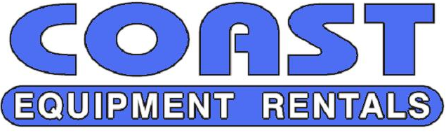
1713 WEST VISTA WAY
VISTA, CA 92083
(800) 361-4500
(760) 941-8003
FAX: (760) 630-8384
Email: info@coastequipmentrental.com

MASTER RENTAL CONTRACT / AGREEMENT

In lieu of getting a signature on the requested rental item, this master rental contract will serve as a blanket agreement to the attached Coast Equipment Rental Agreement of each Rental Contract for equipment delivered by Coast Equipment Rentals. Please have an owner or officer review and sign both:

- This Page
- The bottom signature line of the Coast Equipment Rental Agreement page

In the event that no signed Rental Contract is obtained, an unsigned Rental Contract shall have the full force and effect as a signed Rental Contract.

Owner/Officer Signature_____________________________

Printed Name_____________________________

Title:__________________________ Company Name:_______________________

Date:_________________

Please Fax or Email back.

If Master Rental Contract / Agreement is not received, the equipment will not be delivered.
1713 WEST VISTA WAY
VISTA, CA 92083
(800) 361-4500
(760) 941-8003
FAX: (760) 630-8384
Email: info@coastequipmentrental.com

********** APPLICATION FOR CREDIT **********

INFORMATION PROVIDED TO COAST EQUIPMENT RENTALS ON THIS APPLICATION WILL BE HELD IN THE STRICTEST CONFIDENCE

NAME OF FIRM OR INDIVIDUAL NAME OF CONTACT PERSON

ADRESS AND POST OFFICE BOX OFFICE TELEPHONE

CITY STATE ZIP FAX NUMBER

OWNERSHIP: ____CORPORATION ____PARTNERSHIP ____INDIVIDUAL

___________________________ _____ _________________________________________________
A/P CONTACT EMAIL

NAME (S) OF PRINCIPAL (S) COMPLETE ADDRESS TELEPHONE NO.

FINANCE

BANK BANK ADRESS

ACCOUNT NUMBER COMPLETE ADDRESS TELEPHONE NO.

TRADE REFERENCES

BUSINESS NAME COMPLETE ADDRESS TELEPHONE NO.

CREDIT APPLICATION CONTINUED

PAGE 3

TERMS

All invoices are due and payable on the 10th of the month following the date of the statement… Statements are rendered around the 24th day of each month.

AGREEMENT

We certify that all the information give to Coast Equipment Rentals on this Application for Credit is true and correct. We fully understand the credit terms and agree to the proper payment in consideration of extended credit.

We agree that in the event of default we will be responsible for payments of reasonable attorney’s fees, actual court costs as well as any other costs incurred in the collection of our account.

We understand that finance charges of 1 ½% per month will be charged from the date of purchase on all amounts which have not been paid within 30 days of the date the original statement is rendered.

Our signatures will serve as a notice that we have read and understand and agreed to the terms and conditions as stated above.

Date:______________________________
Signature:_______________________________

Title:___________________________________

